Exercise 8: Academic adjectives 練習8: 學術形容詞

Put the adjectives in the correct place in the table.

形容詞放入表格內正確的位子.

注意: 做成表格 (可以使用Python)

General adjective Academic adjective

short 短 brief 簡短

bad 壞 serious 嚴肅

different 不同 separate 分離

some 一些 certain 某些

powerful 強大 important 重要

clear 明顯 obvious 明顯

usual 通常 common 常見

Exercise 9: Unit vocabulary 練習9: 單位詞彙

Read the sentences and find the missing words to complete the word search.

閱讀句子並尋找失去的單字,完成單字搜索.

注意: 圖片要放在文字左方

1. The b and groom invited many guests to the wedding.

MissingWord: bride

新娘和新郎邀請許多賓客到婚禮.

2. We got married at r o .

MissingWord: registry office

我在登記所得到婚姻.

3. They aren’t married yet. He’s her f___.

MissingWord: fiance

他們還沒結婚.他是她的未婚夫.

4. A marriage ceremony and any celebrations such as a meal or party that follow it: g.

MissingWord: wedding

結婚儀式和任慶祝這餐飲和派對跟隨: 婚禮

5.Did you see her engagement r__?

MissingWord: ring

你有看到她的訂婚戒指嗎?

6. A document that shows two people are legally married: a marriage __.

MissingWord: certificate

一個文件顯示兩人是法律上的婚姻: 結婚證書

7. Don’t be late for the ceremony, you must be p___.

MissingWord: punctual

儀式不能遲到,你必須準時

8. The wedding r__n is at the hotel.

MissingWord: reception

在飯店內招待婚禮.

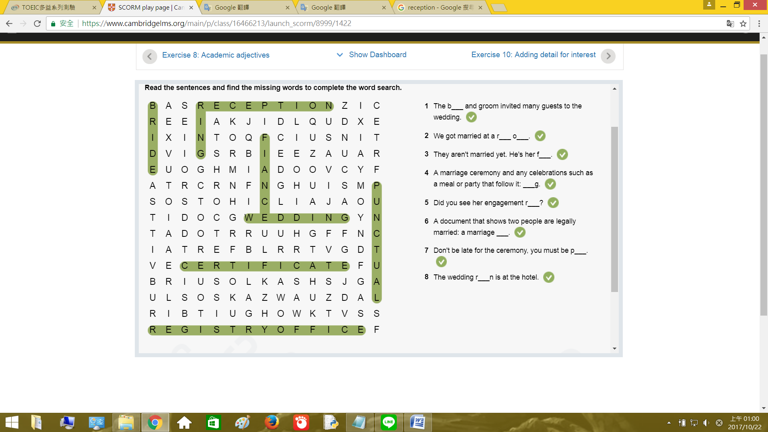

Exercise 10: Adding detail for interest 練習10: 添加興趣的細節

Rewrite the sentences below to add detail for interest.

改寫下方句子添加興趣的細節.使用給訂單字.

1. Families are important. (very)

Rewrite: Families are very important.

家庭是非常重要的.

2. People work there. (local)

Rewrite: Local people work there.

當地人在這工作.

3. Weddings are expensive. (in my country)

Rewrite: Weddings are expensive in my country.

在我國家婚禮是昂貴的.

4. Culture is interesting. (to some people)

Rewrite: Culture is interesting to some people.

文化對一些人是有趣的.

5. Languages are difficult. (can be)

Rewrite: Languages can be difficult.

語言很困難.